Belt Scale Weighbridge Alignment

When Should You Consider Belt Scale Weighbridge Re-alignment? •First, insure that there is no other outside influence on the weighbridge such as rocks, material buildup or any other materials that will cause the scale to read improperly.

•Second, insure that the load cell, load cell cable, and speed sensors are not damaged, or that there are not any defective wires, cables and wire terminals and connections (corrosion).

•Third, insure that the truck scale has been certified and that it also has repeatability. After these have been verified consider the following: When weighed load test accuracy will not repeat. When accuracy can’t be obtained from weighed load tests at different feed rates. When accuracy doesn’t fall within the established allowable tolerances. Belt scale re-alignment requires specific tools to complete this process. Mono Filament Fishing Line (min. 100’). 1-shim pack (1/6”, 1/8”, ¼”). 4-C clamps or wide jaw vise grips . 1-2’ square. 1-felt tipped pen. 1-hammer. 1-punch. 1-25’ tape measure.

When referring to plus (+) rollers/idlers, it means the rollers/idlers that are on the head pulley side of the weighbridge. The minus (-) would be referring to rollers/idlers that are on the tail pulley side of the weighbridge. The Idler is the three rollers and roller support carriage that sits on the conveyor frame. The Stringer referred to is the part of the conveyor frame that the ears of the idler sets on. Troughing idlers should not have the side rollers mounted at more than 30 degrees from horizontal. The objective of the re-alignment process is to better arrange the mechanical alignment of the belt scale. The mechanical belt scale consists of the -2 idler, -1 idler, the weigh-idler, +1 idler and +2 idler. The squaring of these idlers to each other and to the conveyor stringers and mounted all to the same plane makes a very important contribution to the belt scale accuracy. Without proper alignment between each idler, acceptable belt scale accuracy cannot be achieved. Follow the Belt Scale Weigh Bridge Alignment Procedure detailed on this slides notes (steps 1-7) and the next two slides to perform a re-alignment.

Top of Form



Bottom of Form

9+



0:01 / 20:20

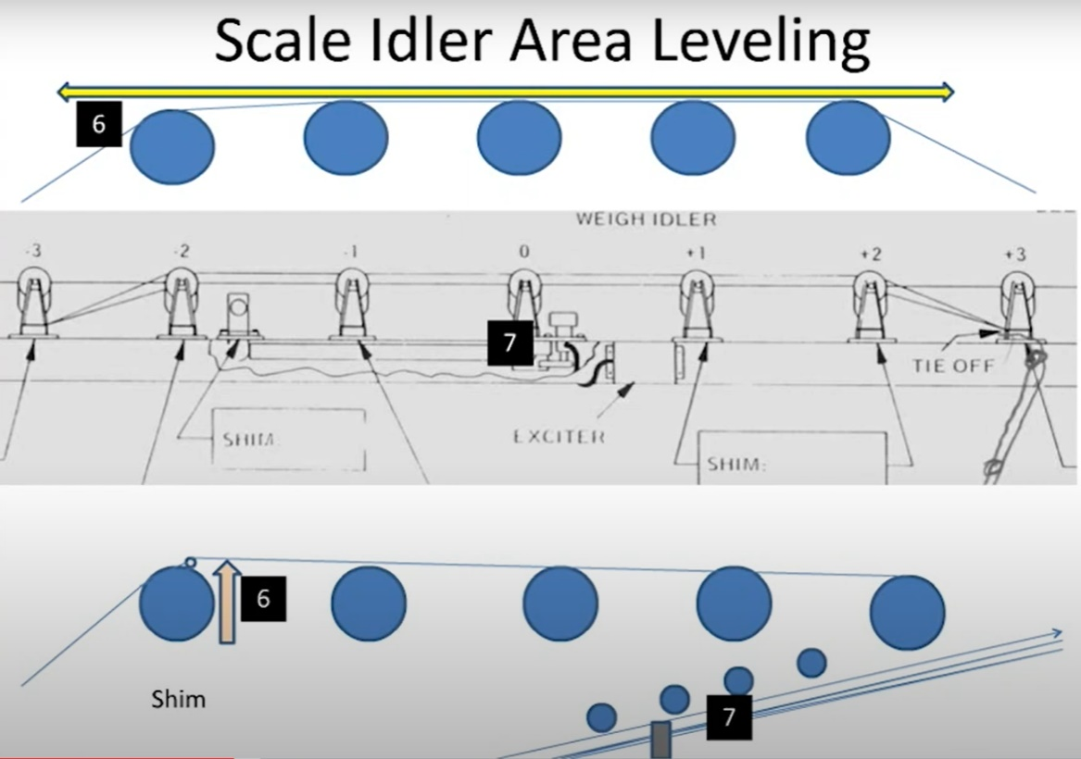

•Lockout and Tagout the scale conveyor motor and any other conveyor or equipment motors that may pose danger while performing the belt scale alignment procedure.

•Loosen the scale conveyor belting generously enough so the belt can be raised above all rollers in the belt scale area. This area includes -2 to +2 idlers and also the weigh idler. •Remove + 1 idlers and weigh idler.

•Measure all three rollers of each idler to find center of each roller. Mark center of each roller with your felt tipped pen. Do this for all five idlers -2 through +2. Center punch all felt tip marks for each idler. •Square the -2 idler to the conveyors stringer or truss.

•Square the +2 idler and the -2 idler to each other by equal-distance from each other on both sides. Then check diagonally the distance to insure square. After these idlers are square, snug the idler hold down bolts.

•Since Step 5 squared the -2 idler to the conveyor frame and Step 6 squared –2 to +2, can we assume that +2 is square with the conveyor frame? No . Check to see that the +2 idler is Square to the stringer or truss (a idler edge being closer to one stringer edge than the other idler edge to the other stringer edge). If not square, recheck the last two steps. If the last two steps were accurate, the stringer or truss is not straight and square. Adjust the square rectangle of the +2 idlers to a happy medium over the stringers.

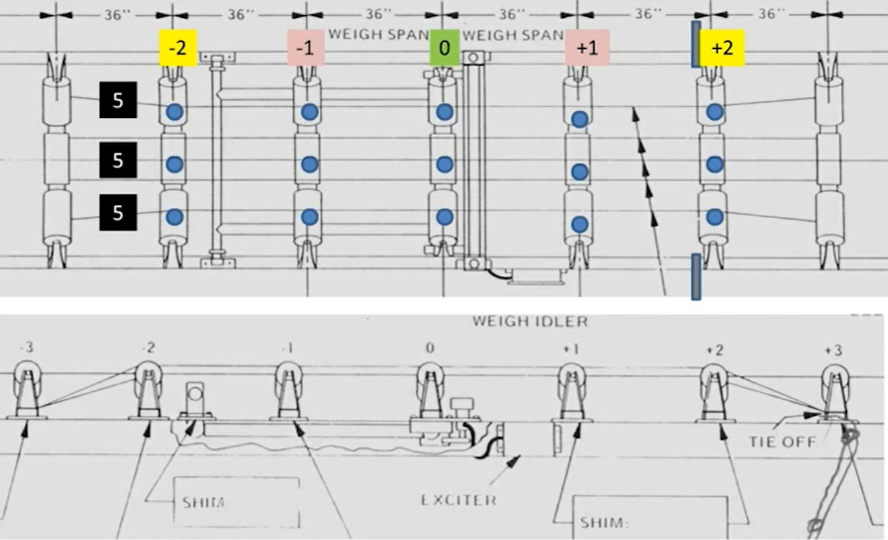•This step requires string line. Consider using 3 fishing rod/reels. They make great counterweights and makes tying not necessary when using the leader hook clasp. The rod/ reel also keeps your line under control. Anyhow, attach mono filament line to the bottom of the -3 idler but over the top of the -2 idler as shown on Figure Four. Extend the fishing line over the same group of rollers for all idlers -2 through +2, tighten the line taut and attach to the bottom of the +3 idler . Do this for all three groups of rollers in the scale area. Align the fishing line over all center punches for +2 idler rollers to -2 idler rollers. •Re-install the –1 and +1 idlers at this time. Equal-distance them to the –2 and +2. They should be square with each other and to the + 2 rollers. Checking for equal measurements (within 1/16”) diagonally and side to side from + 1 roller to – 1 roller proves the rectangle to be square. •Place the +1 idlers height so they are the same height as +2 idlers and that all of the center punches line up with the string line.

•Check the gap between the string line and the idler rollers. The goal here is to position all idlers in the scale area on the same horizontal plane. The string should rest next to the top of the roller. If they are not on the same plane (same height to each other), shim –2 or +2 so they are equal to their respective + or - 1 idler roller. Sometimes it is difficult to determine if the string is slightly touching a + or -1 idler or a + or -1 idler is actually too high and is holding the filament up 1/16” or more. Lift the string at the respective + 2 roller in 1/16” shims under the adjacent 2 idler to determine if shimming of that 2 idler is necessary.

• Re-install the weigh idler to the weighbridge. Equal-distance the weigh idler to the –1 and +1 idlers. Adjust the weigh idler height, by means of the load cell adjusting bolt. Adjust the weigh idler so it just reaches the bottom of the three mono fishing lines located above it. Insure that the center punches line up with the mono lines.

•If the mono filament is not directly over each center punch mark, then loosen the hold down bolts located on each side of the idler and with a hammer tap the idler frame the amount of distance necessary to bring the idler directly under the center punches. Inspect all idlers in relation to the mono fishing line and center punches and adjust accordingly

•Re-inspect the belt scale to insure that all of the adjustments just made have not slipped or has changed, as that will compromise the entire effort.