Steve's notes for Maintenance

R.T.F.M. Read The F**king Manuals!!

These are links that I've found helpful over time. Use the information as you can making your own choices to use the information and/or doing business with them.

Belting:
Martin Engineering links on conveyors
https://foundations.martin-eng.com/learningcenter/basics-of-belt-conveyor-systems
Links for Martin Engineering Pdf books
https://foundations.martin-eng.com/book-form-download-page

Super Screw Belt Splices
https://mltgroup-conveyor.com/permanent-splices-heavy-duty-belts/super-screw-evolution

Baghouse Bag Testing
http://www.etsi-inc.com/section_home.asp?SID=1002

Leak Detection Powder Injector
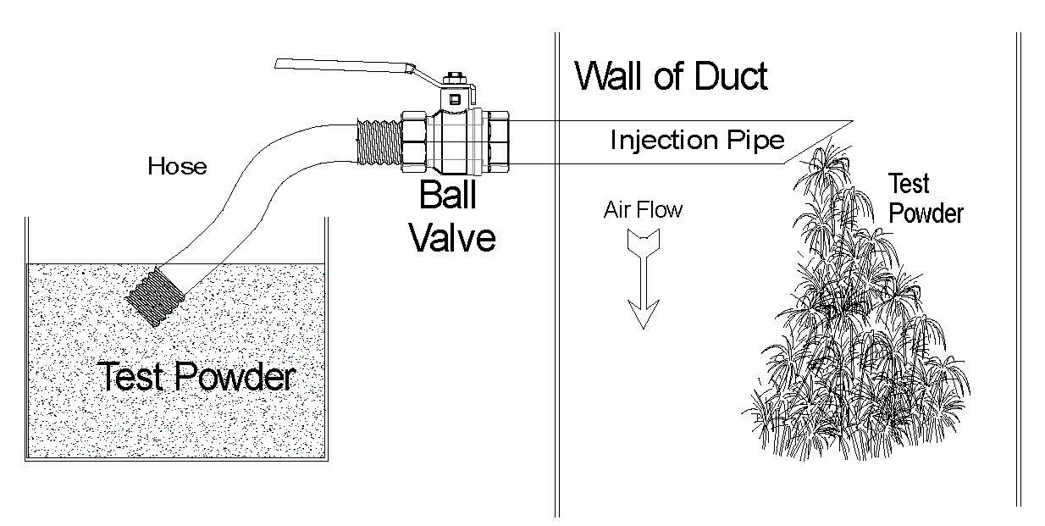

Hot Oil Testing
https://www.paratherm.com/services/heat-transfer-fluid-analysis/

Thermocouple Information
https://www.omega.com/en-us/resources/thermocouple-hub

Solid or Stranded Thermocouple Wire?
Both have advantages, depending on your needs for which one is best for you.
Solid
Normally less expensive.
In a permanent installation where the wire is seldom if ever relocated its a good choice.
Stranded
Initially more expensive per foot.
More flexible, less likely to break on plant moves.
Both
When running TC wire stay a set distance from high voltage wires. Leave extra slack on ends to allow shorting to replace break’s. i.e. its less costly to start with a few extra feet than to be a few inches short when replacing a break close to an end. This will also allow extra flexibility for inserting and removal of probes. Shielding may in the long run be less expensive to sink induced signals from nearby wires.

NAPA Link
https://www.asphaltpavement.org/

Asphalt Institute FAQ
https://www.asphaltinstitute.org/engineering/frequently-asked-questions/asphalt-pavement-thickness-and-mix-design/

Thermal Electrical Inspections
https://www.fluke.com/en-us/learn/blog/thermal-imaging/electrical-systems

Asphalt Service Company
https://motionengineering.net/

Combustion Analyzers for Asphalt Plants, WHY?
https://www.enerac.com/asphalt/

Rental Testing Equipment
https://www.trsrentelco.com/

M.S.H.A. on Guarding
https://arlweb.msha.gov/s&hinfo/equipguarding2004.pdf

Toolbox Talks
https://arlweb.msha.gov/epd/efsms/toolbox/previous.asp

Handouts from Clarence Richard Workshop’s
https://ezfloweighing.com/training/
Drop down from training for Safety, Process Quality Control, or Plant Production Attachments.
Speed Control
4-20 or 0-10?
0-10 was one of the first inputs used for controls. Speed control started out as 0-110vac on the panel that went back to the speed controller where the 110 was reduced to 0-10 volts ac then changed to DC control voltage. With this 0 volts was zero input and by getting this from the ac input the zero feed can not cross zero to a negative speed signal. A lot of the older controls could not follow crossing zero. With 4-20ma signal a true zero of the 4ma and a full speed trimmed at 20ma.
Type of Drive, DC (Direct Current), VFD (Variable Frequency Drive) or Eddy Current Drive
Steve's take on Drive History
The original drives on cold feeds were DC to handle the needed low end starting torque and operate at low speeds. This required the controls to operate on single phase power to the DC controllers. The next set of drives used was Eddy Current. With Eddy Current a 3ph motor is combined with a magnetic clutch that with increased speed signal couples more power to the load while the motor runs at full speed. 3ph Frequency controls have advanced to the point that with a suitable motor they now offer good starting torque and low end drive speeds.

